**Sample Questions Part II**

1. In the diagram below, which is the node with highest betweenness centrality? Calculate the betweenness score of this node and show your calculations. Speculate (but don’t calculate) which node may have the second highest score. Justify your response.

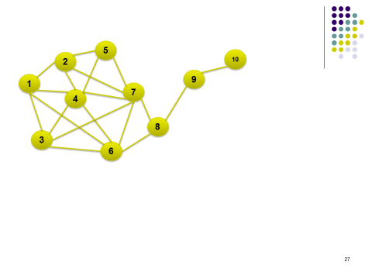

**Answer:** Node 8. It is the only true bridge without which the network gets split into two. For calculations, refer to Zoom recording for session on betweenness centrality. Unscaled betweenness centrality of node 8 is 14.

Either 6 or 7 should have the second highest betweenness score. While they are not bridges like 8, all communication between the body and the tail of the kite must pass through either 6 or 7. But because there are two of them, their score will be lower than that of 8, but higher than that of anybody else.

2. A survey was conducted within cohort of 65 students, which asked each student to indicate which 3 students in the class s/he corresponds with the most on Facebook. The Professor then used this data to draw the social graph and calculated the betweenness centrality of each student. The average betweenness centrality came out to be 200.

If the Professor had looked up each student on Facebook and created a social network between these 65 students using the actual friendship or contact list, would the average betweenness centrality be above 200? Justify your response.

**Answer:** The average betweenness from the real network would be **less** than 200. The real network will be more dense than the one created from the survey. Thus there will be more paths between pairs of nodes, which will lower the average betweenness score.

3. Consider friendships between football jocks and computer nerds at the famous Adams College (from the movie “Revenge of the Nerds”) as shown in the network below. Does this network exhibit homophily? Show all calculations.

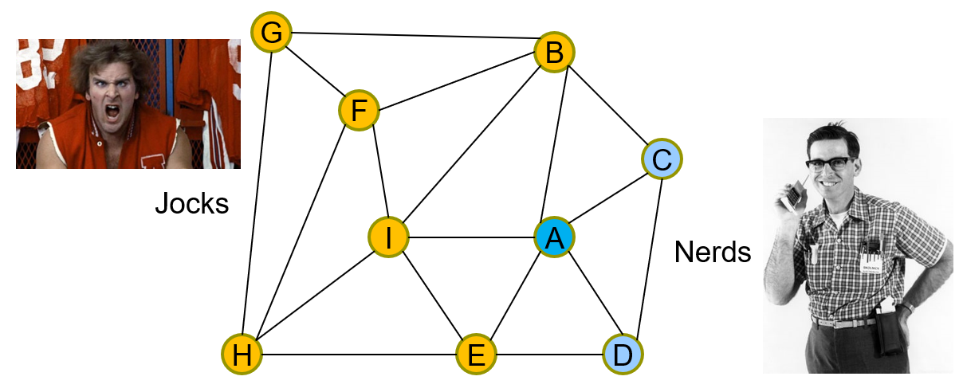

Answer: Get some basic facts:  
Total number of nodes = 9

# Nerds = 3, # Jocks = 6. Thus the probability of finding a nerd is 3/9 = 1/3, and that of finding a jock is 6/9 = 2/3. If friendships formed randomly, then the chance of a link with a jock on the left and nerd on the right is (1/3) * (2/3) = 2/9. But the other possibility – a jock on the right and nerd on the left has to be considered as well. The probability will still be 2/9. Thus the probability of a random friendship between a nerd and a jock (regardless of who appears on the left or right) is 2* 2/9 = 4/9.

Now let’s look at the actual network above. There are 18 links or edges, and 5 of these are cross-edges (nerd-jock or jock-nerd). So the actual probability of a nerd and a jock being friends is 5/18, which is a lot smaller than the 4/9 value we got above. Thus the actual chance of this type of friendship is much less likely when compared to that based on random friendships being formed. This suggests that there is a strong presence of homophily in this case (nerds are more likely to be friends with nerds, and jocks with jocks).

1. Find the largest 3-core sub-network from the network below:

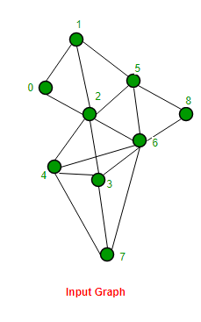

**Answer**

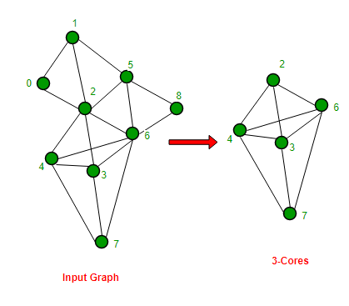

1. Consider k-cores and n-cliques. “If we choose k = n-1 (and n > 2), we are likely to find more cores than cliques from a given network.” Do you agree with this statement? Explain your position.

**Answer:** True. An n-clique is a subnetwork of n nodes which are fully connected, while a core of comparable size does not require all nodes to be connected to each other. Naturally it is easier to find the latter.